**Analytic Memo 2**

**Jessica Lewis, 9/17 – 9/21**

1. **What data did you collect this week?**

Tuesday 9/18

* Quiz #2

Wednesday 9/19

* Reviewed the what a blog is, the purpose of it, and how it can help us understand math.
* Based on *Discussion #1,* students read original posts from their peers and commented on 2 peer posts.
* I completed the **Teacher Observation Form** for each student.

Friday 9/21

* Based on peer comments, the students were instructed to either reply to their peers’ comments or add to their original response.
* I completed the **Teacher Observation Form** for each student.
* Since Discussion #1 is over, I also filled out the **Blog Evaluation Rubric** for each student

1. 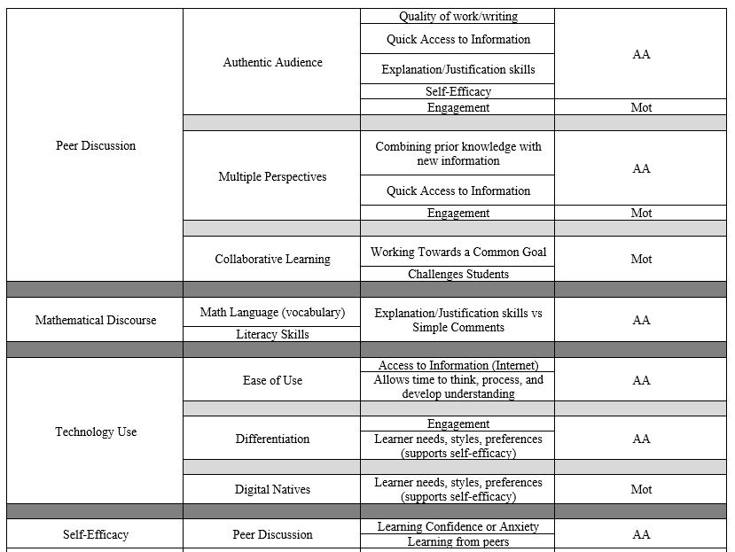**Review the qualitative data that you collected this week. List five to ten words (potential codes) that come to mind as a result of this data.**

This week I attempted to organize my codes. I started by reading through my thesis paper and writing down reoccurring words and themes. I then organized it into a chart to help display connections.

1. In a table, share the quantitative data that you collected this week. This data **should not be individual** according to student – but should be presented in the form of **averages or percentages**. Write a short explanation (one or two sentences) of what you think this data means in terms of your research question (s).

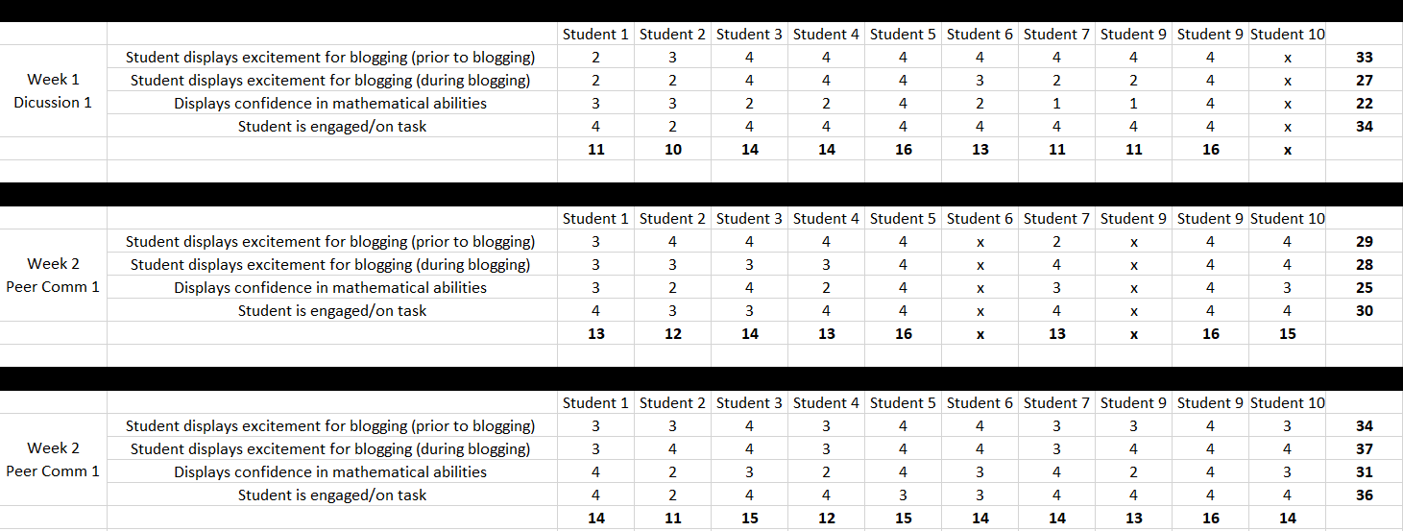**Teacher Observation Form**

There is a significant difference in students’ motivation to complete the blog from week 1 to week 2. This may be because we reviewed what a blog is and its purpose for understanding math. In week 1 students answered the discussion prompt with an original post. The students did not start to engage with peers until week 2 when they read and commented on their peers’ posts. I think the students enjoyed interacting with their peers on the blog and as a result were more motivated to participate in discussion.

After our last meeting, I asked the students what they gained from the blog discussion this week. They said they gained further understanding about positive and negative integers by reading examples from their peers. Some of the examples they may not have thought of on their own.

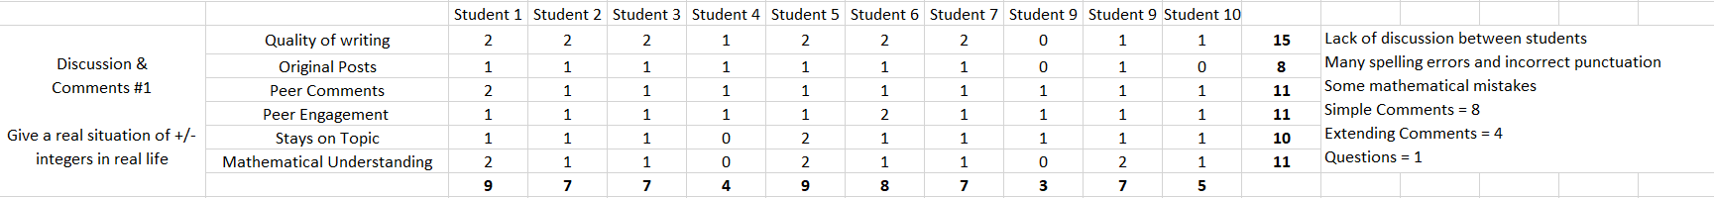**Blog Evaluation Rubric**



After reading and evaluating the blog discussion, I found that there is a lack of discussion between students. Comments are simple and do not question or extend understanding. I found many spelling and grammatical errors which could affect the readers perception of the post. Keep in mind these are 7th grade math support students who are also low-level readers. It may take some practice and time to develop the skills needed to write higher level comments.

**Quiz 1 & Quiz 2 Scores**

1. **Write at least one paragraph (it could be more if you like) reflecting on your experience of the week in terms of both student performance and your own practice.**

I am happy to see that student engagement and motivation has improved from week 1 to week 2. Research surveys revealed that students enjoy writing more when they know someone else will be reading it; in addition to the ability to write and receive comments from peers (Clayton & Pringle, 2013). I believe finishing up a full cycle of a discussion helped the students see the benefits of the blog and as a result increased their motivation for participating in discussion. I know that going forward I must focus on developing their critical thinking skills to help them write posts and comments with deeper meaning.

My plan for this week is to give them a discussion prompt that forces them to activate their explanation and justification skills. I will do this by posting one of the problems from their homework on the blog. I am going to use a collaborative learning activity that challenges them to get everyone to successfully solve the problem using only the blog. Collaborative learning is an instructional strategy that involves a group of students working together to achieve a common set of goals (Kuo et. al, 2017). Using a scenario where they may not be able to verbally talk to each other, they will not be allowed to vocally discuss their procedures. They will have to write their explanation for solving the problem on the blog without revealing the answer. By challenging them as a group, they will hopefully be forced to write explanations that are clear enough for the reader to understand. This will hopefully spark conversation between students given they have a question or need further explanation. I also plan on getting their feedback as to whether this was helpful and if they would use this for homework help in the future.

1. **Write a few sentences (it could be more if you like) outlining the way that this week’s memo is different from last week’s memo.**

This week I have more organization and structure to my data collection. I also started a code bank and coding web which helps me see connections between the data. Having collected to weeks of data I can now see growth in student motivation. My hope is that students will also grow in their explanation and reasoning skills. This will hopefully happen as students continue to write on the blog.

Having collected some data has also helped me alter some of my plans for student achievement. Based on data results, I think my 7th-grade students need to feel more of a physical benefit from the blog to find it useful. Thus I plan to focus the next discussion question around a problem specifically from their homework. If they find the blog helps them complete their homework, they will hopefully see the benefits and purpose of the blog and use it on their own in the future.

**Field Notes**

**Week 1 – Discussion Post 1**

* Students disappointed when found out it was a math blog
* Students struggle to read and understand the context of the question
* Spelling and grammar issues
* Concerned with peer audience
* Lots of questions about discussion prompt (explanation skills, peer audience)
* Authentic audience – affected their writing
* Literacy – low explanation skills – found in writing

**Week 2 (Wed, 9/19) – Peer Comments 1**

* Reviewed what a blog is, whats the purpose of our blog, and why is it important in math
* A student asked me to read her post to make sure it made sense
* S: “Explain your reasoning and learn from your peers”
* Talked about simple comments vs thinking comments/questions
* Deeper level thinking comments
* Students engaged in verbal discussion with person next to them to confirm some of their thought about the blog post

**Week 2 (Fri, 9/21) – Peer Comments 1**

* Some students off task and chatty
* T: “Do you feel like you peers help you learn?”
* S: “Yes, some of the examples I would not have thought of on my own”
* Students are working together verbally on some of the posts
* A students wasn’t sure what to write on a post, directed him to choose another post